**Scenario’s with OnPrintShop Screenshots**

**Scenario 1**

A one off cash customer walks into the shop and wants some double sided business cards to be printed; they have bought in a hand written mock up. The administrator prepares the pdf and uploads it to the backend. The system produces a price. The customer wants the same day service, so a 20% surcharge needs to be added and the job needs to be marked as urgent. They pay for the job and agree to return at 4pm to collect it, they wish to take proof of payment with them, the administrator prints out an order/receipt for them and asks if they would like to have it emailed to them, they indicate that they would. When they return to collect the invitations the administrator marks the job as complete (collected). The next day the customer returns to say they found an error (The administrator had incorrectly spelled a name) so the administrator reloads the corrected pdf for the job but does not charge for this one, she notes in the system that it is a rework. She again marks it as urgent and the customer agrees to return to collect it later that day. When they return the customer checks the invitations and is happy, they ask for a second receipt with the zero charge in the total, which the administrator prints out as well as emails to them.

**No Job prioritisation**

**Go to orders, off line order, add a customer**

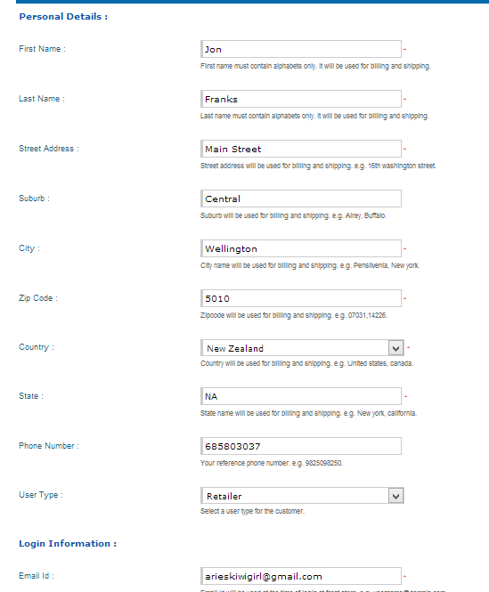

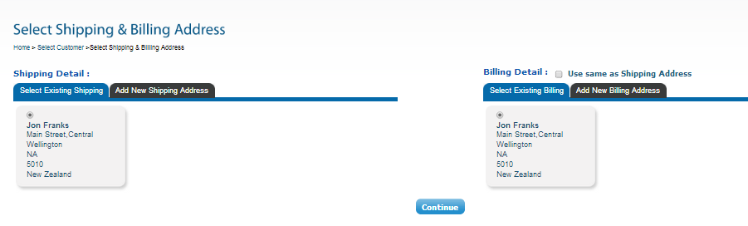

**Add a custom product**

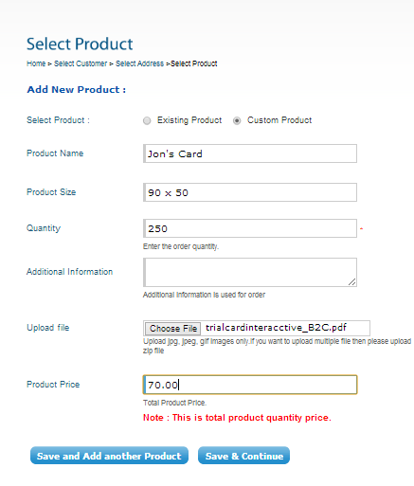

**Save and continue- did not allow to upload a pdf?, uploaded a jpeg to see where it headed, may have to design online…apparently not**

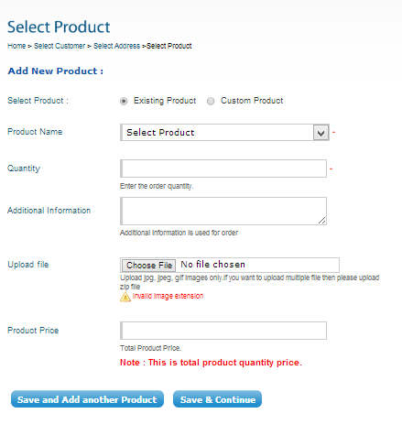

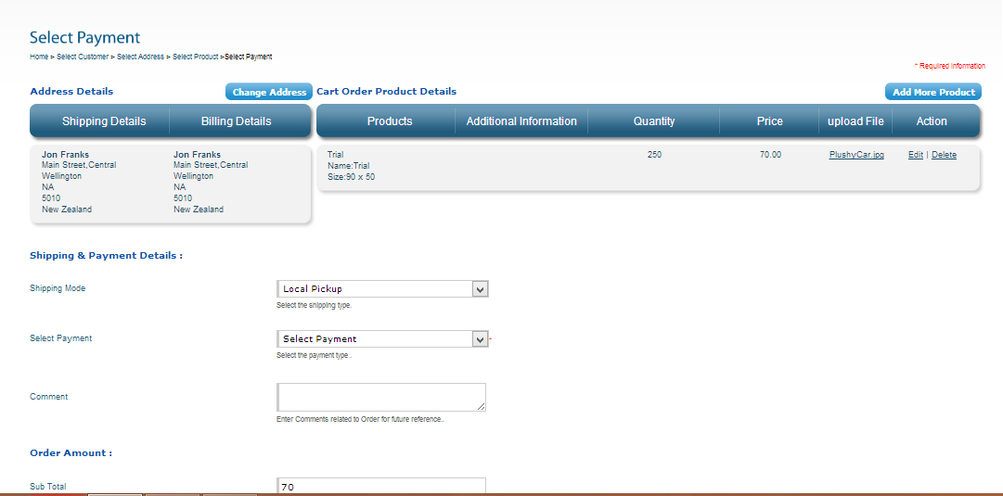

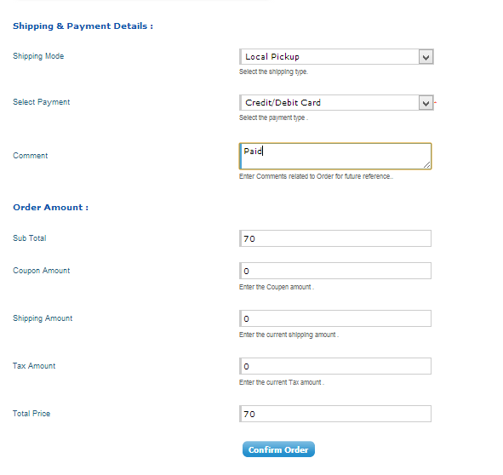

**Confirm order, says order has been added successfully but doesn’t add it to the list, click to view order, ops accidently clicked search, lost the link to the offline order**

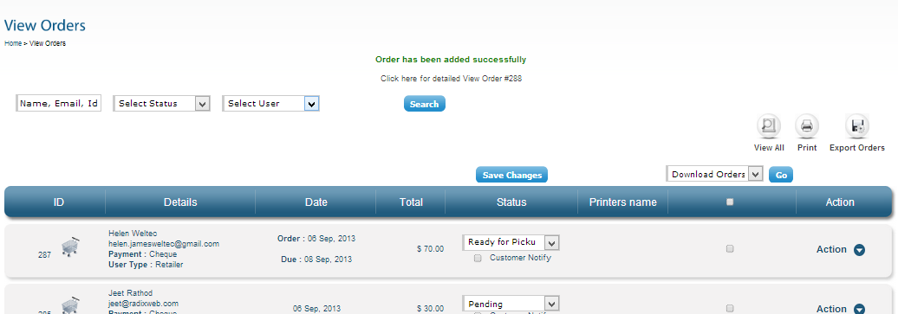

**At the bottom of the orders**

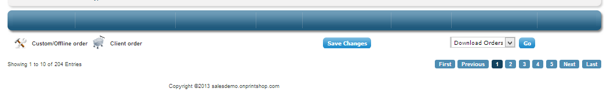

**Can’t seem to access order 288! Demo site not fully functional.**

**Scenario 2a,**

An on account customer logs on and requests a quote for a one off run of laminated A4 forms, they upload there artwork and send the request for 40 copies.(This may need to be done by email???). The administrator prepares the quote but also notices that there is a mistake in the artwork and the layout isn’t that great, she amends it and returns it for approval with the quote. The customer approves the quote (email or online) and requests that it is couriered out, the job is loaded. The printer retrieves the pdf and prints the job, it is marked as ready for lamination. The laminating is completed and the job is marked ready for couriering. The courier details are added and an email is sent to let the customer know it is on its way. A packing slip is printed and included with the job. The invoice is ready to be loaded into xero and the job is complete.

**Log in, Click My Quote, Click Create Quote, Click Custom Quote, fill in form, upload artwork**

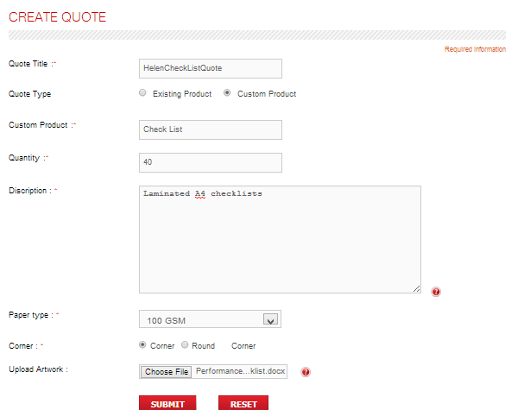

**Click Submit**

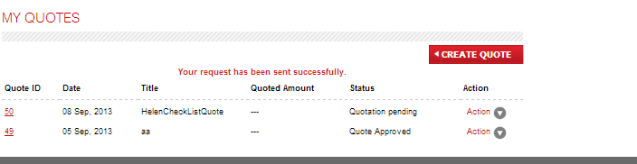

**Log in to Admin**

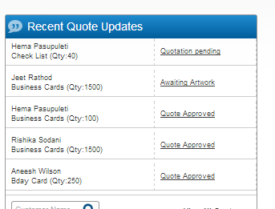

**Click on the Quotation Pending**

**Download the uploaded artwork**

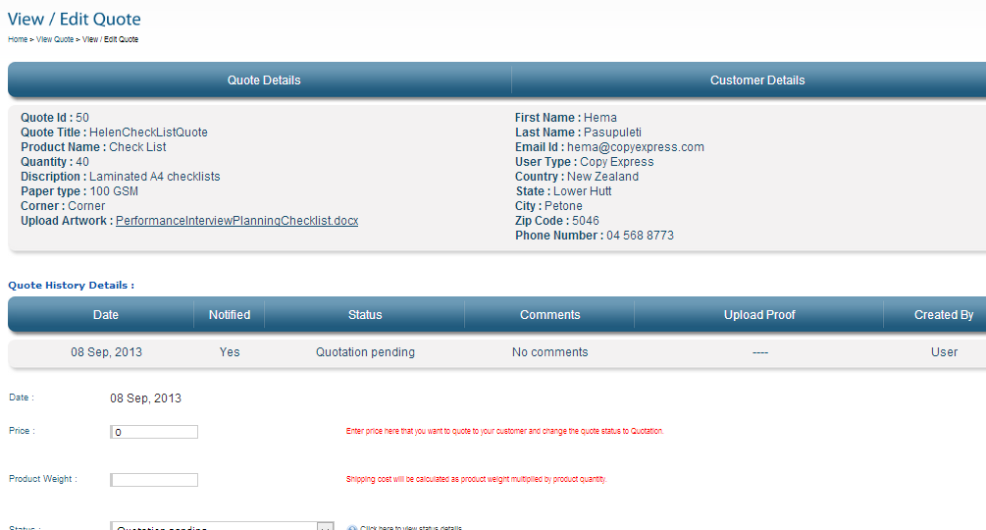

**Didn’t like my word .docx**

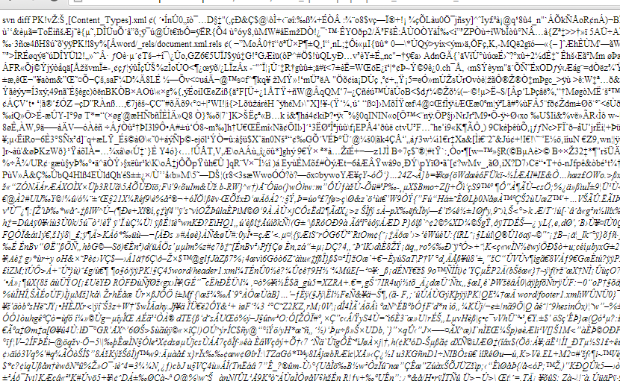

**I changed the file to a PDF, filled out the quote, clicked save**

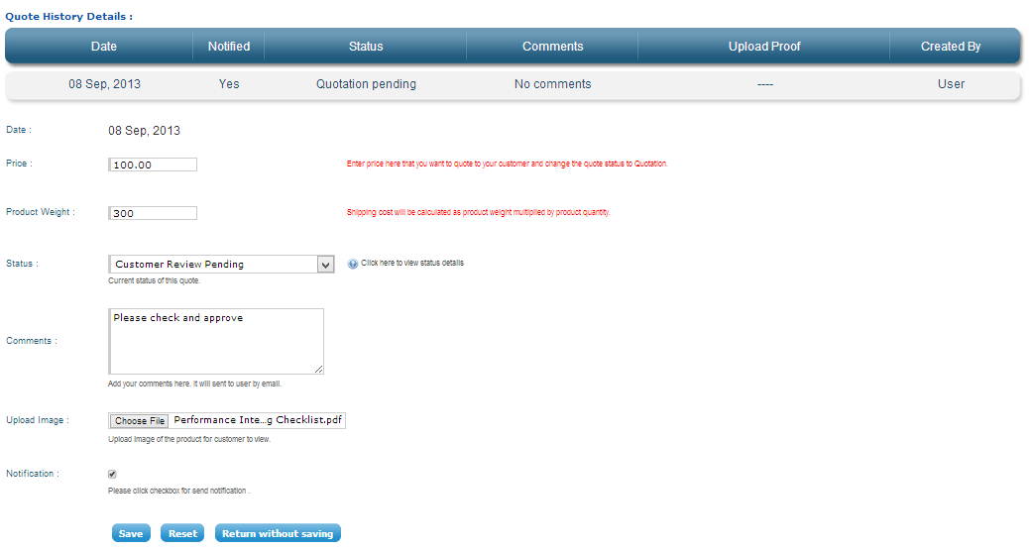

**Got a blank screen, clicked back**

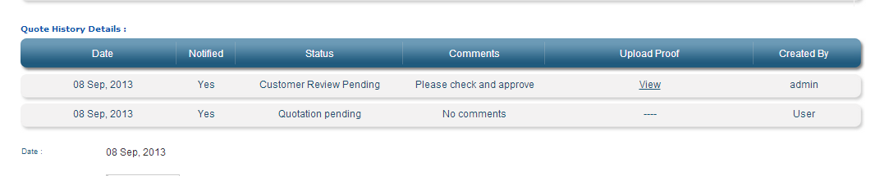

**View the uploaded quote, but can’t approve it!**

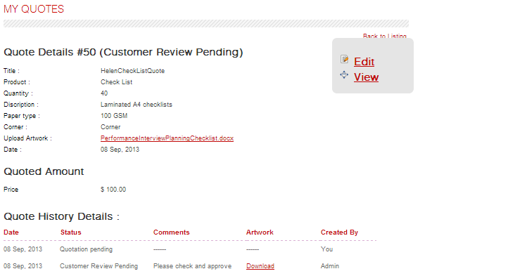

**View the pdf, it is the uploaded one not the corrected one, this bit can’t be working yet on the demo site.**

**Scenario 2b**

An on account customer logs in and find the business card they wish to order, they edit it and add a photo; the save a copy to draft and then log out, later they come back and make one more change. They preview it and are happy; they add the order to the cart and proceed to check out. The job is seen at the backend and processed, as for the first scenario (I don’t think we need to demo this bit twice)

**Log in, click Business essentials and then Business cards, scroll down,**

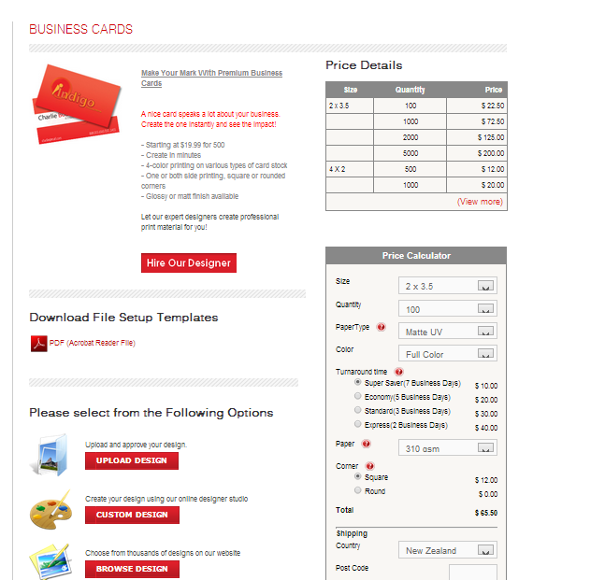

**Just the same as the B2C site**

**Scenario 3**

A returning customer logs into the B2C website. They find a business card template and upload their own photo and enter their details. They add the item to the cart and place the order, they indicate that they wish to collect the print work from Copy Express and opt for internet payment and an email is sent to them. The job is seen on the back end (How do they know it is awaiting payment?) and when the payment is received it is taken off hold and a due date is generated and email sent. The job ticket is printed and the job is processed; the status is changed; an email is sent to alert the customer that the job is awaiting collection; a receipt is generated and put with the job.

**Log in, go to business cards, design my own, image gallery, upload image, browse to photo and upload, click on the image and add it to the card (Helen Weltec; Password Printer1)**

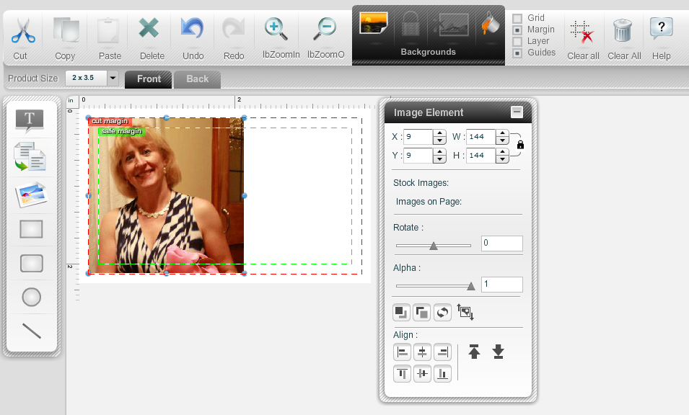

**Resize etc, add text, and background and then save as HelenBusCard**

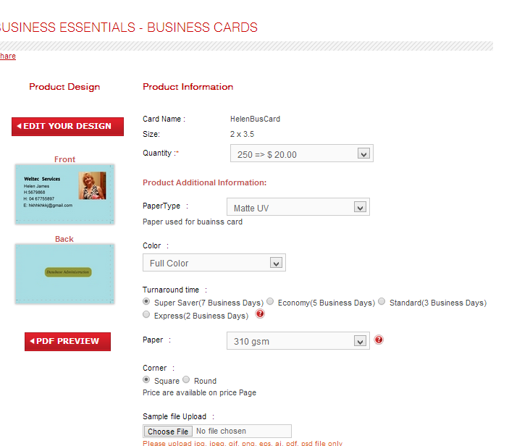

**(Logged out and back in the design was gone, my images were there though – re did it, clicked the agree to terms and save and continue a second time, the card now showed in my portfolio and shopping cart)**

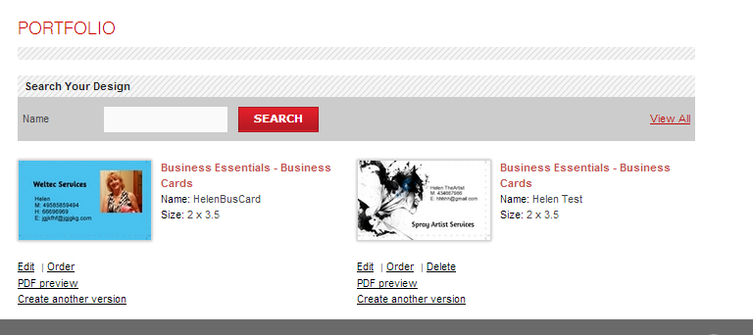

**I also tested using a supplied background**

**Log in, design my own business card (the online editor is quite good but can’t send to back, cant watermark, cant fade etc. –need to compare to ePrint, don’t think they can either)**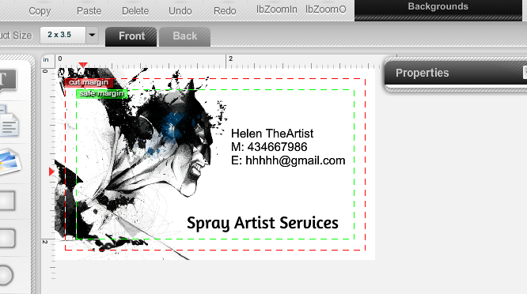

**Save and Continue, name it Helen Test**

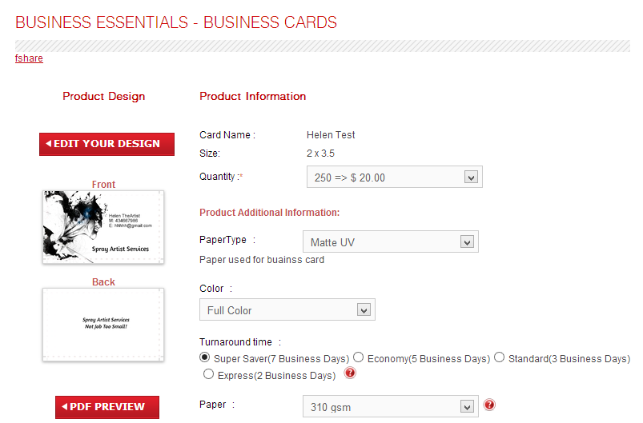

**PDF Preview downloads it for you to look at or if you hover over the card it shows it in a larger size.**

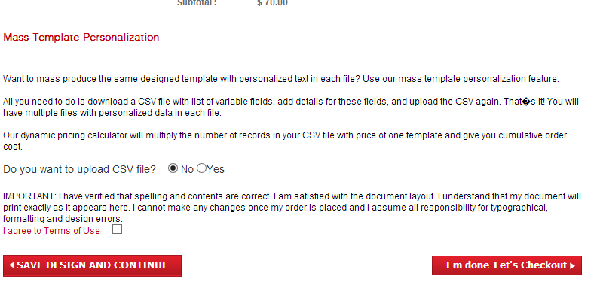

**Nice feature, but why would you offer it for a business card?**

**To check out you must agree to the terms!**

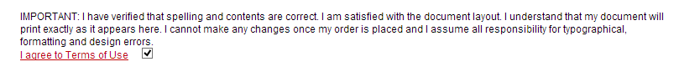

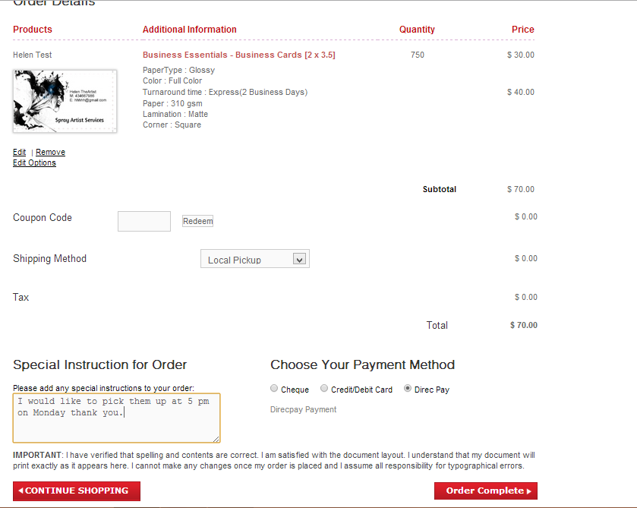

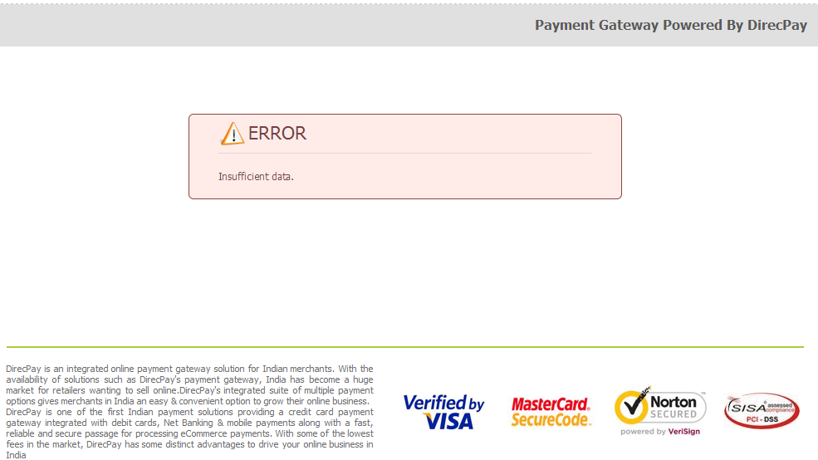

**Didn’t like the Direct Payment option (Just a Demo flaw), changed to pay by cheque**

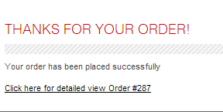

**View my order**

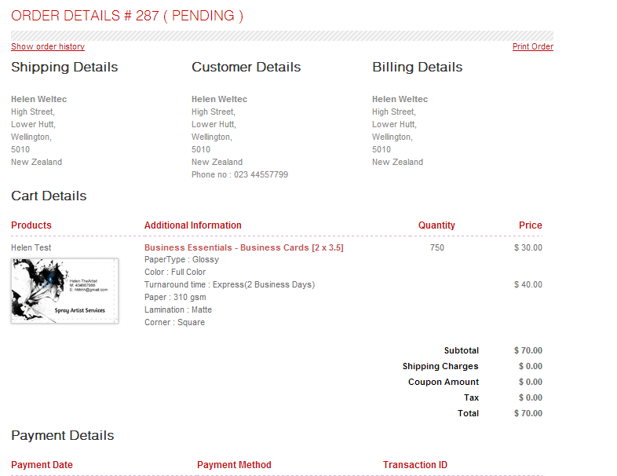

**Log into Admin**

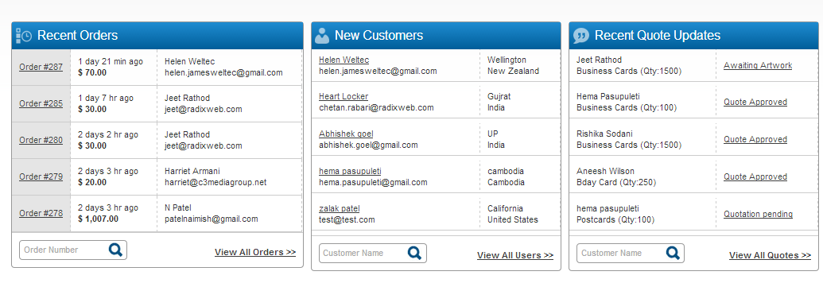

**Select My Order**

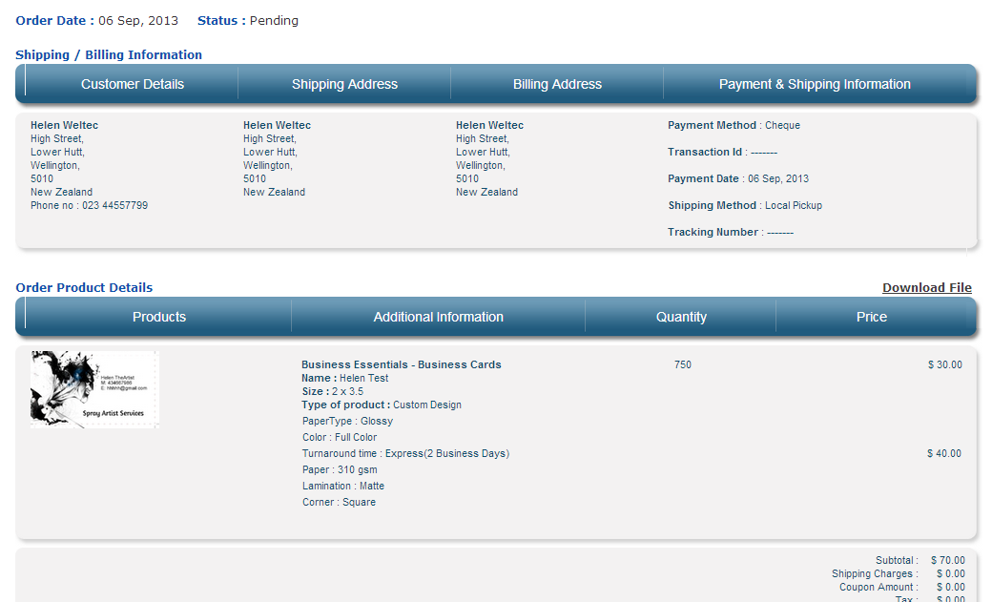

**Click download file, comes down in a zipped folder**

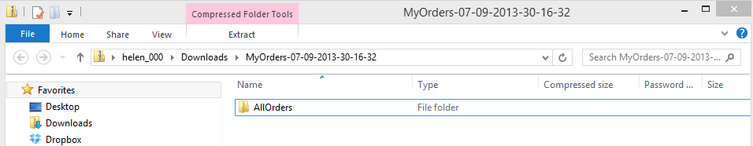**Right Click, open**



**Right click open**

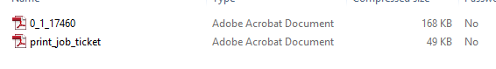

**Job Ticket, shows the comment added by customer**

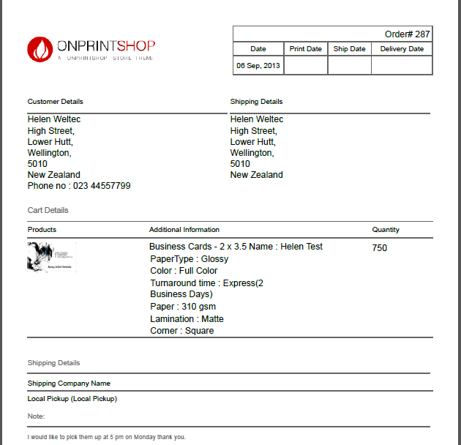

**Job PDF**

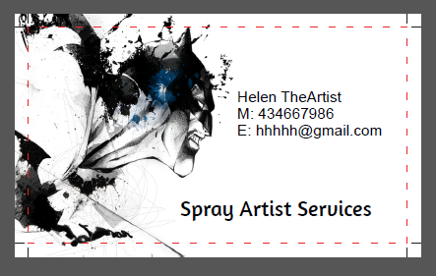

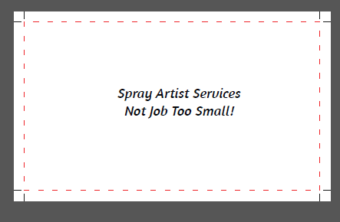

**Update job from pending to in production, save**

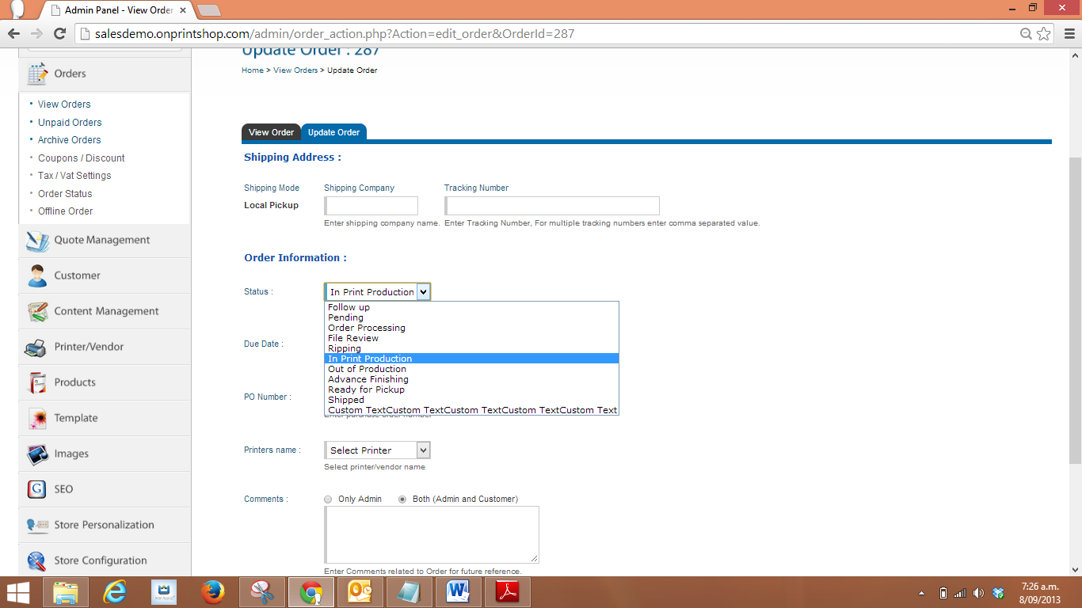

**Can enter the due date here and courier details, due date doesn’t show on the job ticket**

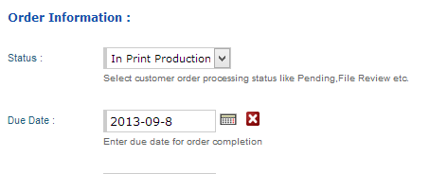

**Log in to my account to check the status of my order…now in Production, gives an option to reorder**

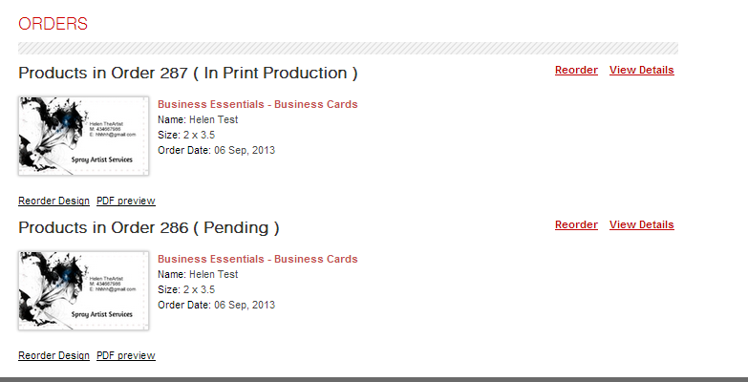

**Back to Admin,**

**View Orders**

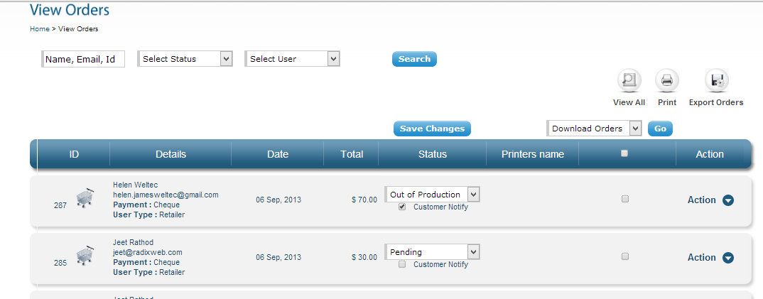

**Change to out of production, click notify customer**

**Click Action, assign job**

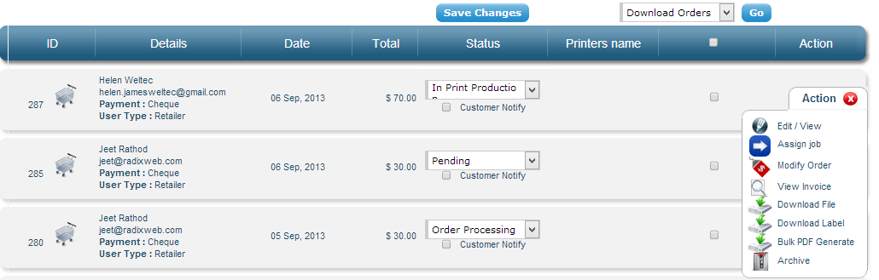

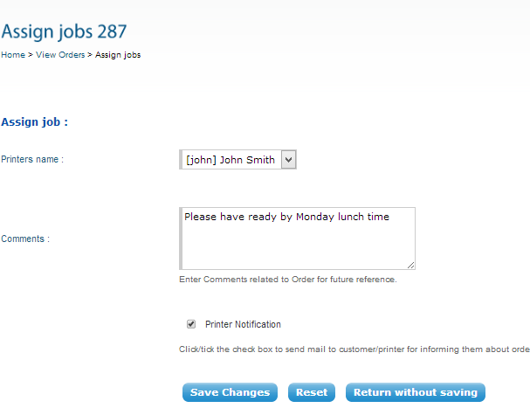

**Modify order (Can change the price or quantity if you wanted to, but not the turnaround time).**

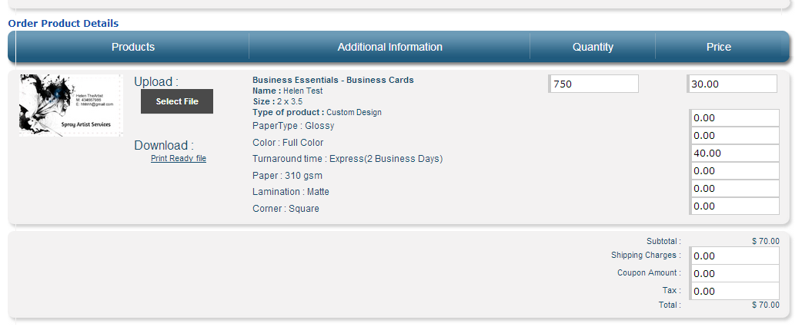

**Out of Production, notify customer, save changes (Received a blank email, may need setting up? Tried adding a comment in the update order, clicked notify customer, still only a blank email)**

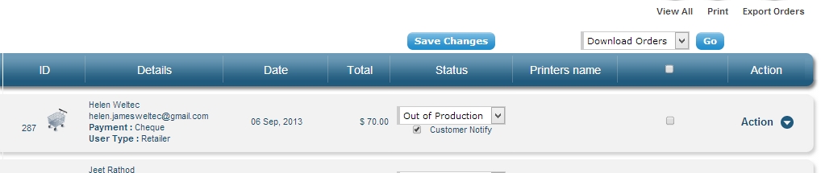

**Review order online, shows history**

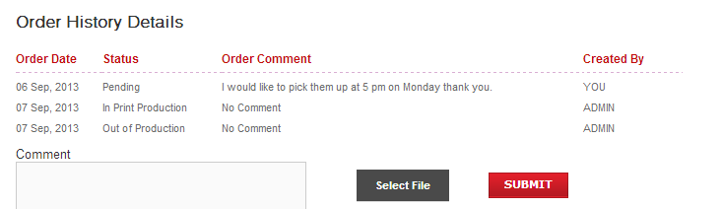

**Action, view Invoice, downloads the PDF that can be printed**

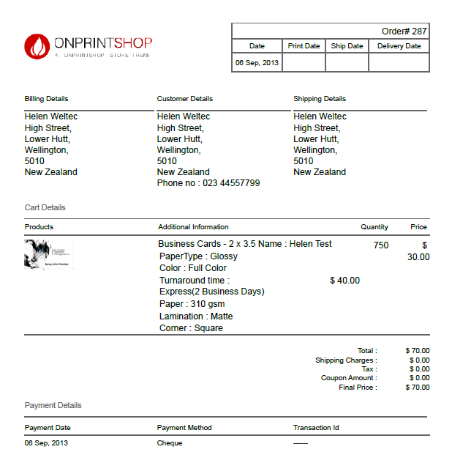

**Job picked up, so click action, archive the order, it disappears off the job list.**

**If customer returns for a rework, go to archive orders on LHS, click the order Action and click restore, change the status to what you want it to be.**

**NB My card now shows in the backend under Customer - Customer templates, will need to delete it after the demo as it has my photo on it!**

